# TFS

# Basic GitHub Desktop User’s Guide

# Table of Contents

|  |  |  |
| --- | --- | --- |
| Connecting GitHub Desktop to GitHub Enterprise Server |  | 3 |
| Cloning a Repository |  | 6 |
| Creating a Branch |  | 9 |
| Committing and Pushing Changes |  | 11 |
|  |  |  |
|  |  |  |
|  |  |  |
|  |  |  |
|  |  |  |

# Connecting GitHub Client to GitHub Server

1. Download GitHub Desktop Client here: <https://desktop.github.com/>
2. Open GitHub Client  
   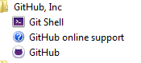
3. Click the Gear icon in the top right corner

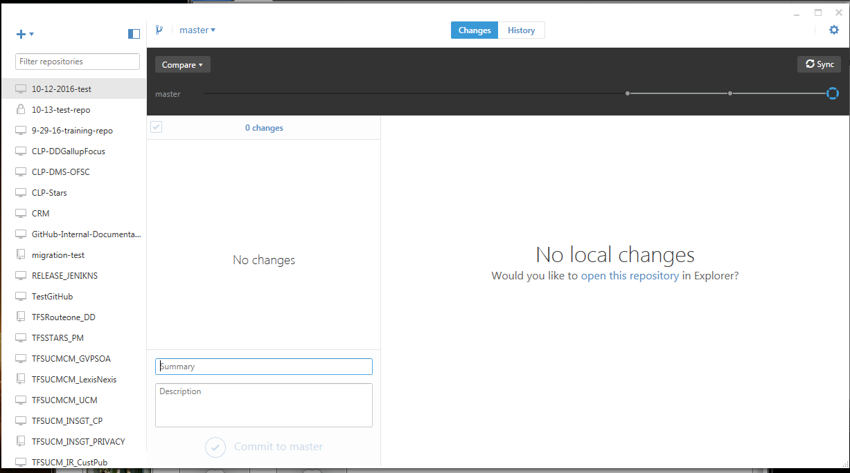  


1. Select Options  
   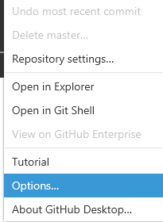
2. Click “Browse” to navigate to and select the folder where you wish to import your data to and export your data from  
   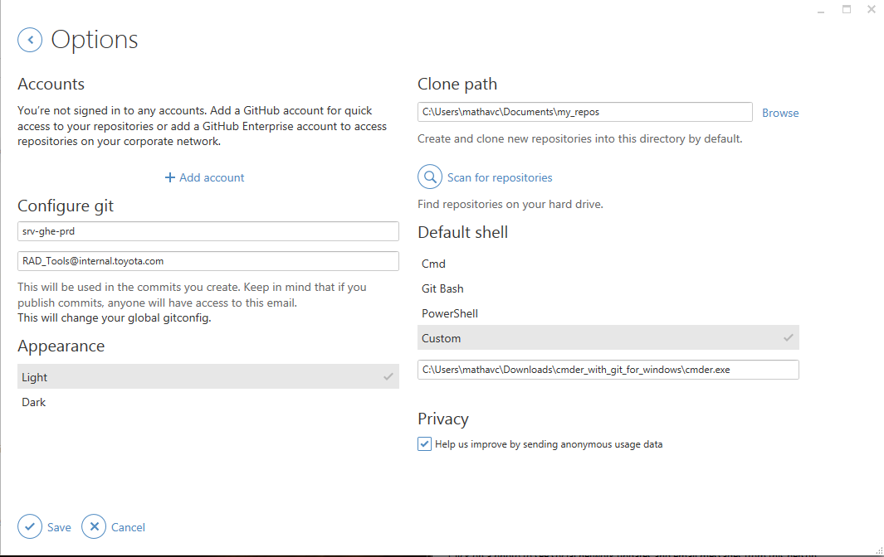  
   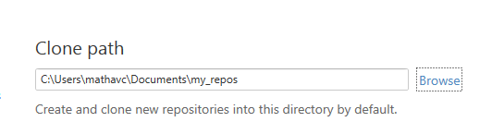
3. Go to “Add Account”

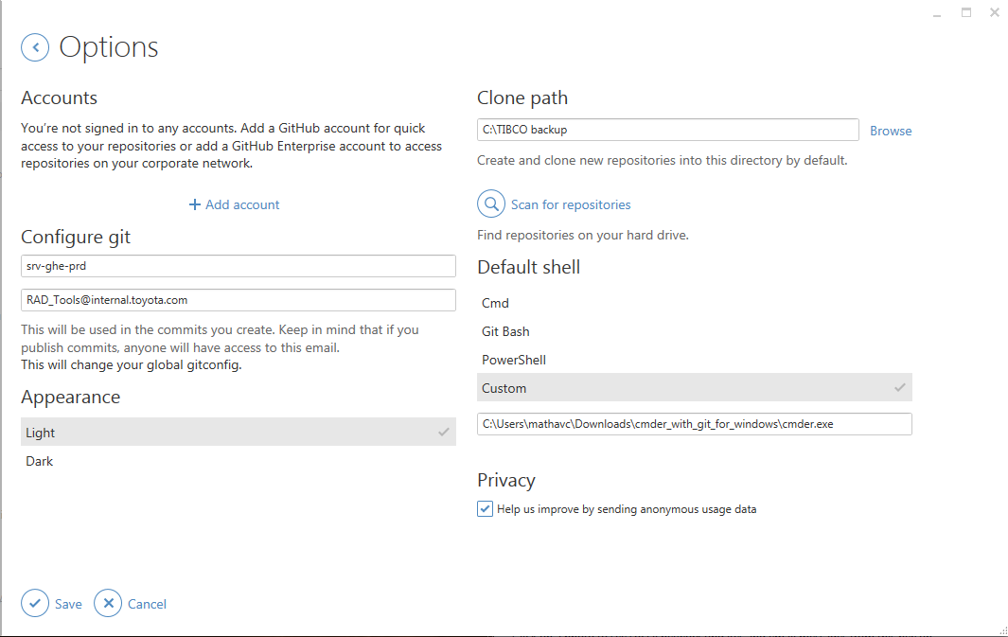

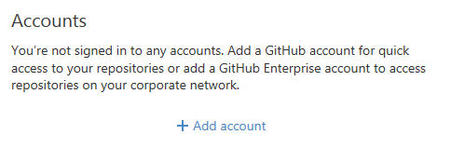

1. Select “GitHub Enterprise”

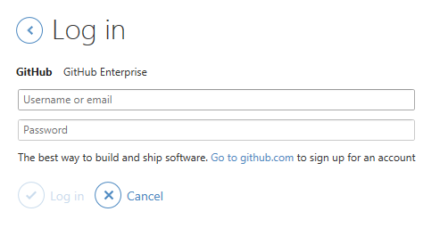

1. Input your Lan ID and Password. For GitHub Enterprise server address enter <https://xpvapl0170.tfs.toyota.com> and click Log in  
   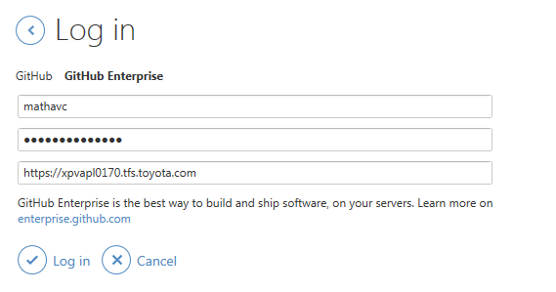

# Cloning a repository

1. Click the “+” sign in the top left corner of the window  
   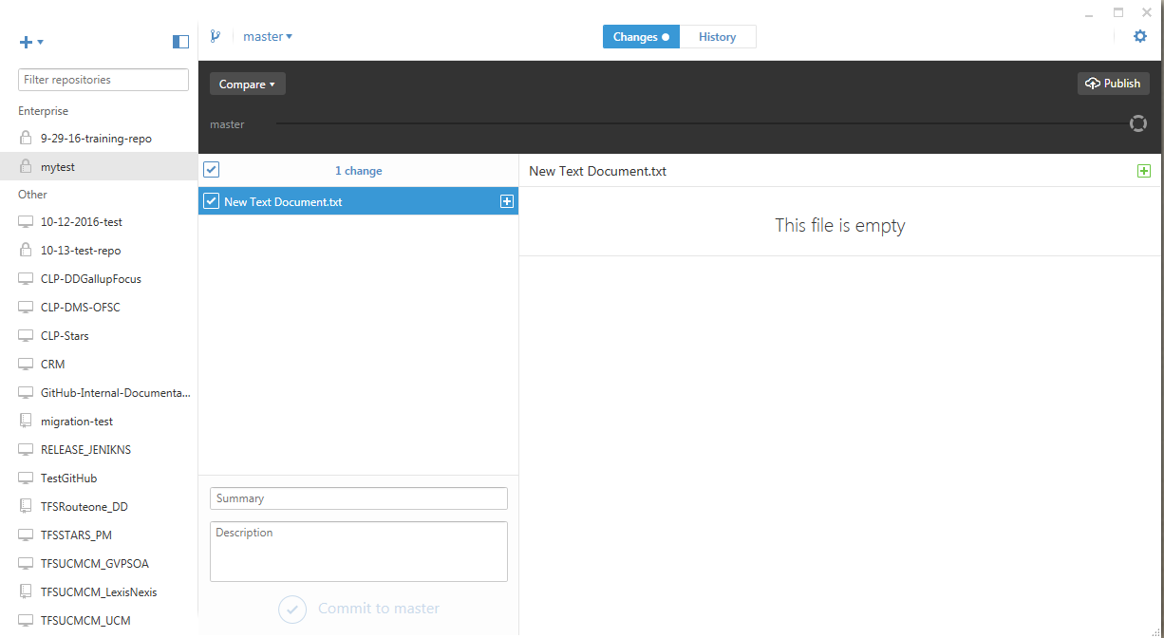
2. Click “Clone”  
   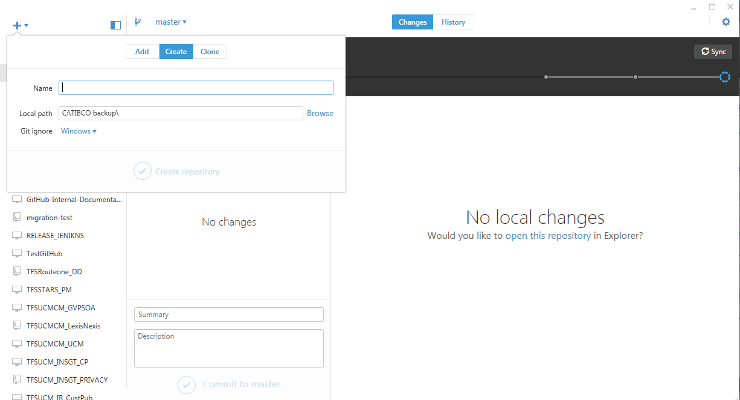
3. Select your organization if you are cloning an organization repository or your username if you are cloning a personal repository  
   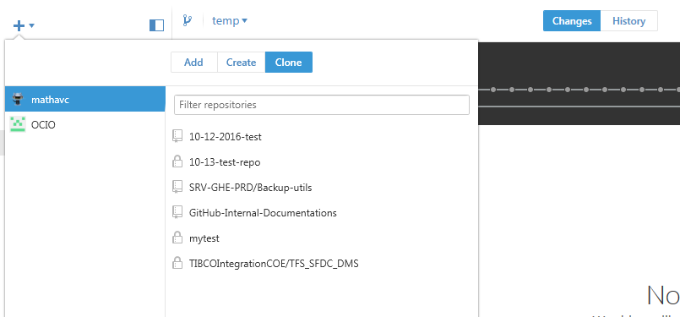
4. Select the repository you are cloning  
   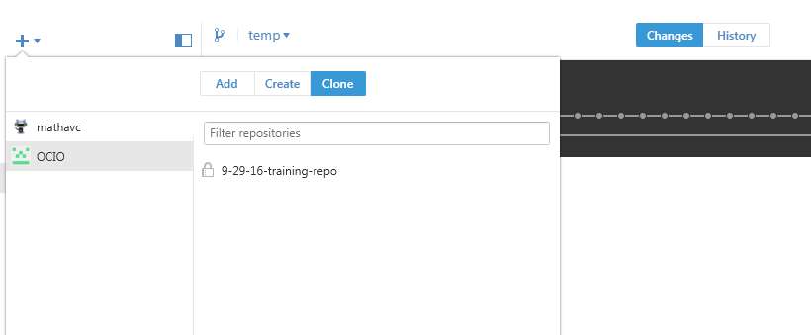
5. Click the checkmark next to “Clone [name of repository]”  
   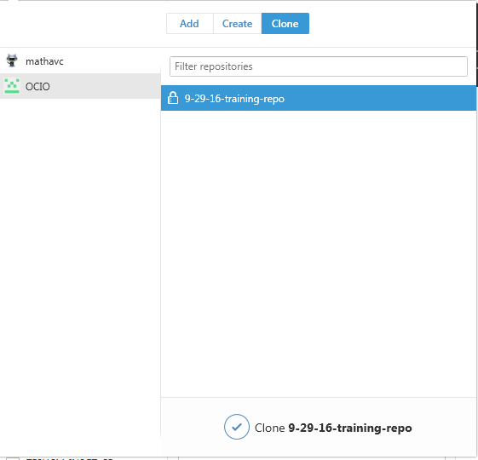
6. Use the Window that pops up to select the folder you want to store your repository in. The cloning process will create a folder to store all of your information in, so you only have to select the parent folder, not the exact folder where your data will be kept.  
   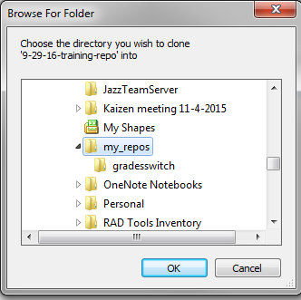
7. Your repository will clone. After this screen is gone you can interact with your files using your code editor. Added files and changes made to existing files within that folder will be tracked by Git.  
   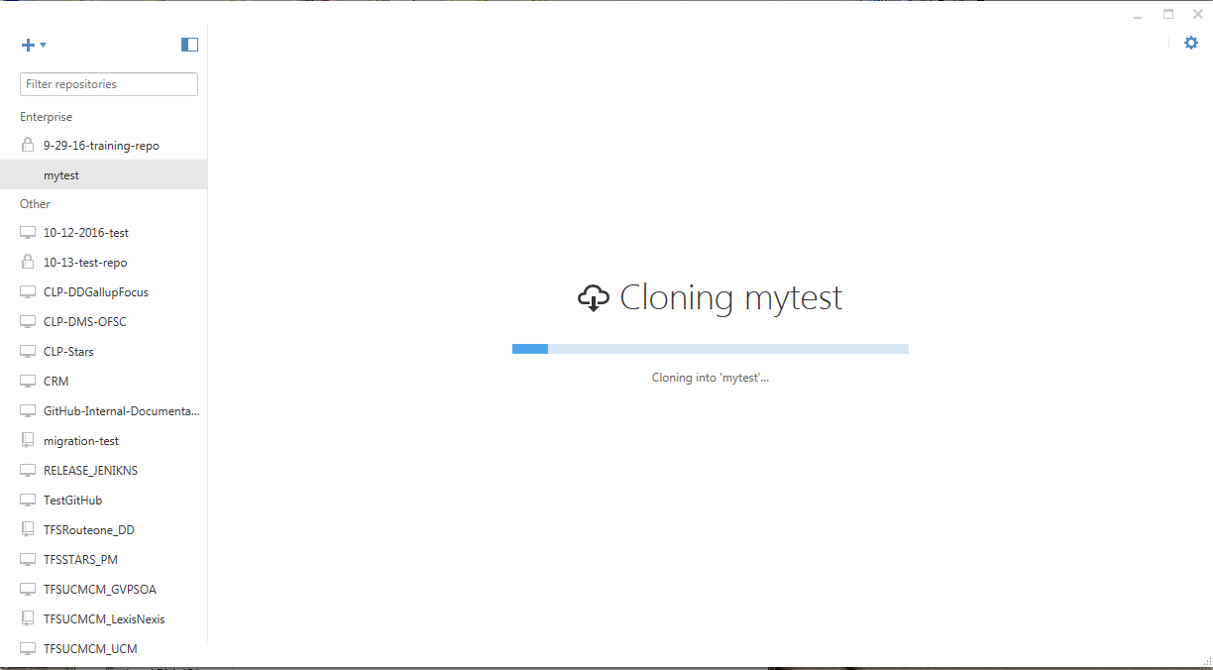

# Creating a Branch

1. Select the repository you need to work with.

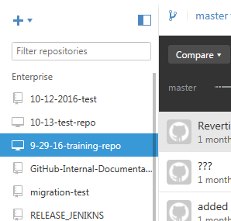

1. Click on the Branch icon  
   
2. Give your new branch a name. eg. “Hotfix Branch” or “Release 0.9 Development”
3. Click “Create new branch”  
     
   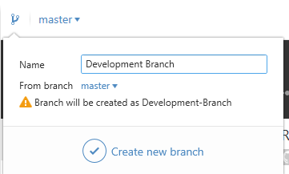
4. The name at the top will change from “master” to the name of your new branch to reflect that you are now working on a branch other than the Master branch, and the timeline will reflect that you are working on a branch as well.  
     
   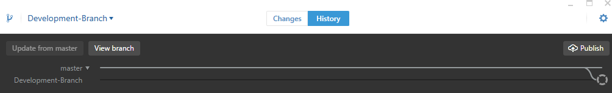

# Committing and Syncing Your Changes

1. When you are ready to save the work you’ve done to your repository open the GitHub Desktop Client  
   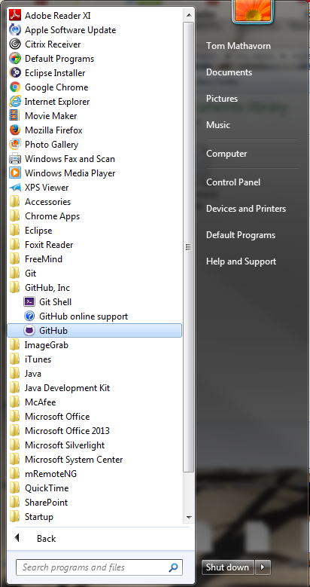
2. Select the repository that has changes to commit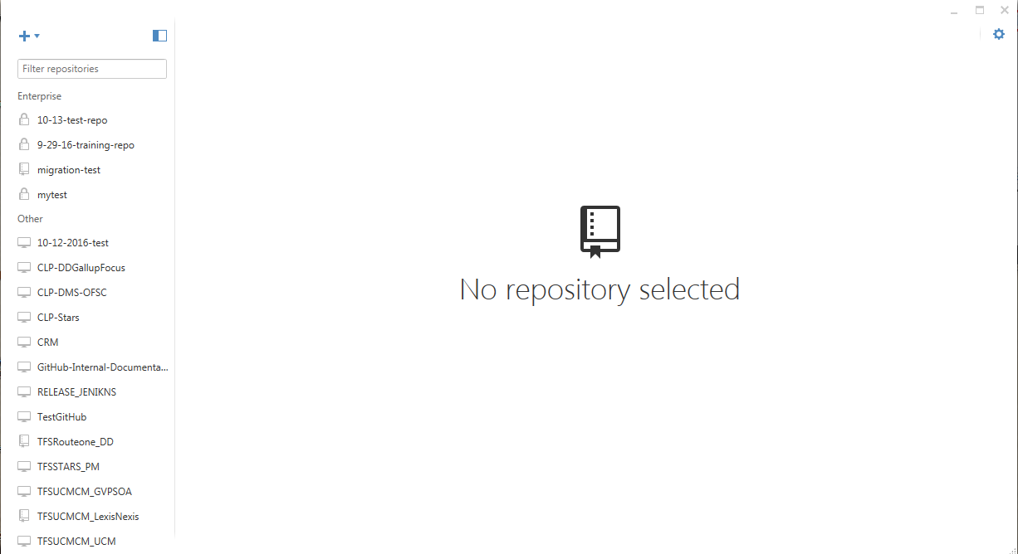
3. Select “Changes” at the top of the window. GitHub will indicate that it detects uncommitted changes by placing a dot next to “Changes”  
   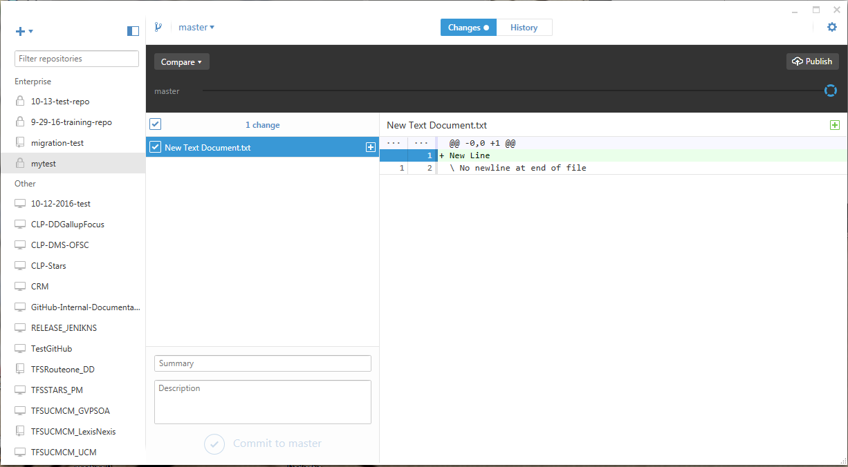
4. In this section GitHub will show you what changes you have made to the repository.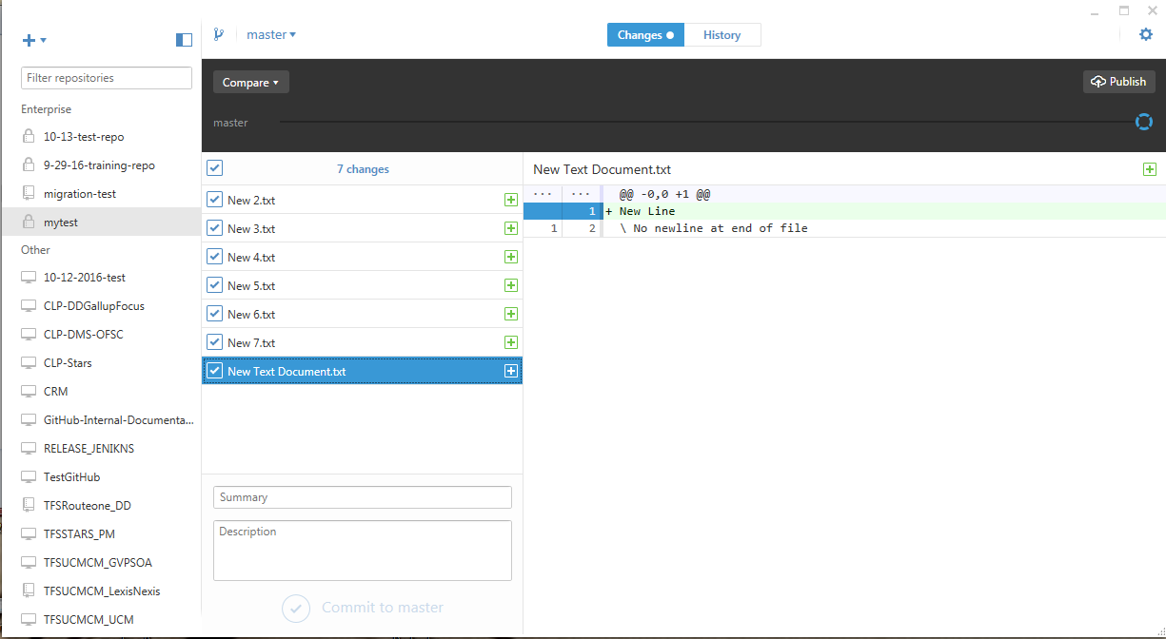
5. If you select one of the edited files. GitHub will show what changes were made to the file in the highlighted box.  
   
6. Enter a brief message describing what work was done for this commit. A more detailed description can be added in the box below.  
   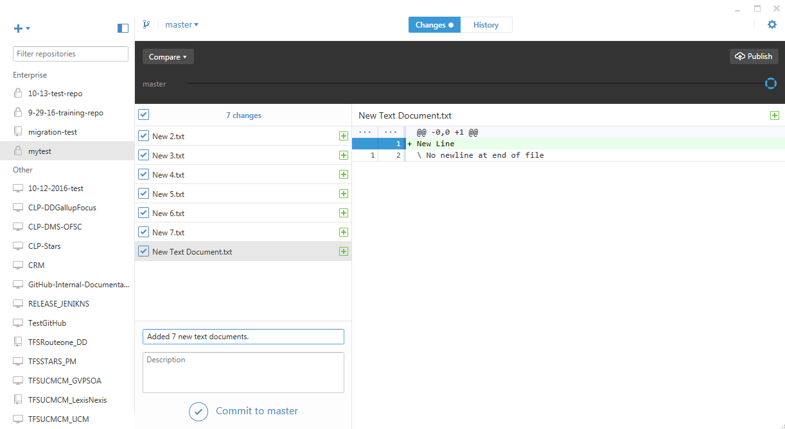
7. Click “Commit to master”  
   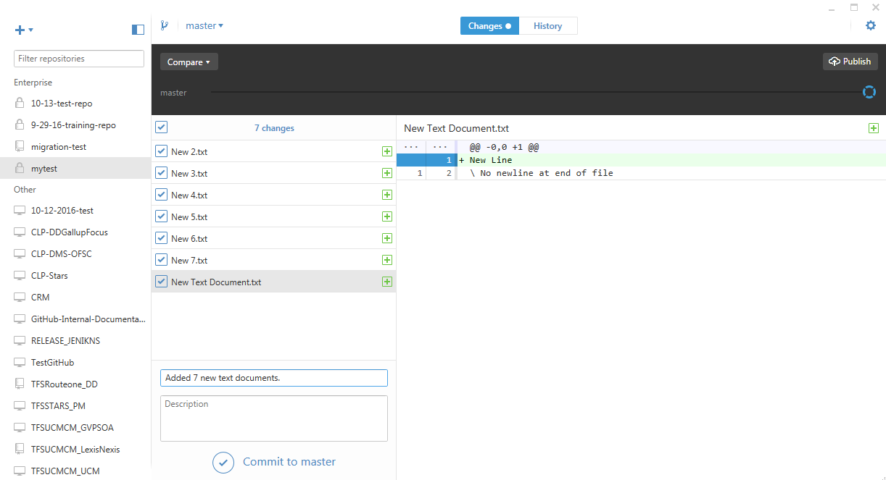
8. Your commit will be displayed in the upper right corner with an empty circle. You can hover the cursor over the circle display more information.  
   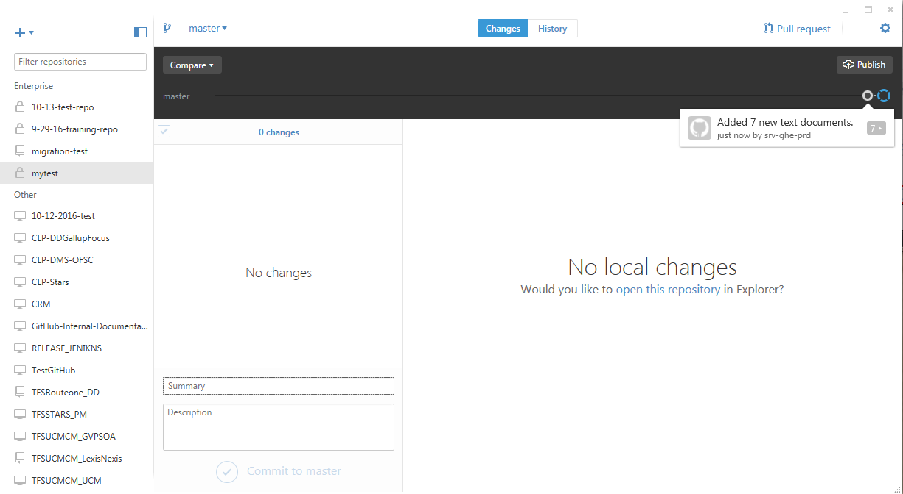
9. To sync your changes to the server click “Publish”  
   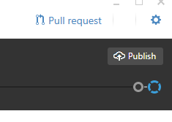
10. 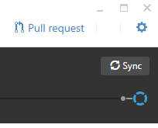  
    You will know that your commit has been synced to the server by the small dot instead of an empty circle